The Newsletter for Middleton on the Wolds

Issue No 41
SEPTEMBER 2022

Advertisement

NEXT COPY DATE

14th SEPTEMBER

I am pleased to see that we have 2 Middleton residents taking advantage of our special rate for private sale ads. (page 19) It made me think of items in my loft that I could advertise but I need the time to sort them out - maybe next month ….
Wolds Pizza has paid for their advertisement to be our front page this month, would this be a good idea for your company?
Please send in your contributions by the end of the copy date. If I don’t acknowledge them please get in touch to make sure they have arrived.
Thank you
Lyn
4 The Paddocks 219500 middletonflyer@yahoo.com

ADVERTISING COSTS for the Messenger

Rates Month Year

Whole Page £25 £150
1/2 Page £15 £100

1/3 Page £10 £60

Small private sales advertisements - 1/4 page - £5
Full colour - Print run 500 copies
Contact: Tina 01377 217242, middletonflyer@yahoo.com
email: middletonflyer@yahoo.com page 2

Editorial

Phew! What a scorcher! As someone once had it. As heatwaves go this one has been a belter. Hottest since whenever; driest since a week before that; creating most moans since – well, since the last period of abnormal weather had people banging on about the heat; the cold;
the wet; the dry. The weather!
The thing is, we have been told that we should expect extreme weather conditions more often from now on, so we’d better find ways of coping with them. For a start we’ll have to use less water, both in the home and, probably more importantly, in the garden. It means weaning ourselves off the hosepipe and starting to use water butts and ‘grey’ water. (I know someone who manages to save water from the washing machine and uses that on the garden. I don’t know how it’s done but you’ve got to admire commitment like that). As well as trying to use less water how about reducing your overall need for water? If some plants cope with arid conditions better than others, then they’re the ones you should be growing. I’ve noticed that, although my grass is a nice shade of light brown, the bits ‘plagued’ with moss and clover are still green. So, I’m getting rid of the grass and replacing it with clover. A bit of a no brainer, really, especially as it hardly needs mowing. That’s what you call a ‘win, win’!
But enough of Gardeners’ Question Time, let’s just make the most of the weather we get. After all. we can’t do anything to change it; maybe we should think about changing ourselves.
Stay safe,
Mike

If you have any ideas, comments or complaints (especially complaints) you want to share then send an email to middletonflyer@yahoo.com.
Remember, we can’t respond unless we receive your message.

QUIZ PAGE
- Alfred, an ancient King of Wessex, is famous for burning what?
- Who sang about being an eggman and a walrus?
- Who was the lover of the Roman known as Marc Anthony?
- Which ocean surrounds the Maldives?
- Which is the most northerly of the Channel Isles?
- Which famous novel featured Jo, Meg, Beth and Amy March?
- Home to the Ross Sea and a species of flightless bird—where is this?
- I have a cake and a table named after me, and I'm used all round the
In the long-running British TV series Coronation Street, what was the
- name of Minni Caldwell's cat?
- What takes place in Hong Kong's Happy Valley?
Quiz set by Rowland Wooldridge
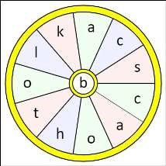
All answers on
page 16

SEASONAL WORD WHEEL

Try to find the timely 3 words and then
create as many words possible with the
letters in the word wheel. You can only
use each letter once and every word
must include the letter in the centre of
the wheel.

SUDOKU

email: middletonflyer@yahoo.com page 4
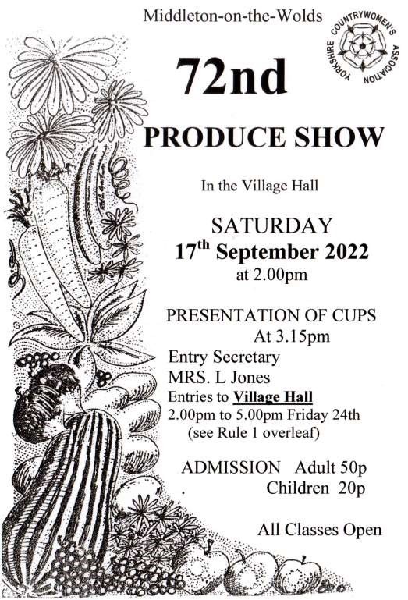

16
th

Village hall
Dates for your diaries:
Saturday 1st October - Driffield Middle 8 Singers (see opposite page)
Saturday 26th November - Christmas Fair - there are
still some tables for hire - please contact Sharon at sroe.general@gmail.com or on 217254
Friday 17th March - Due to popular request, Edwina Hayes makes a return appearance. Tickets to be on sale in the new year.

Hall Rental
If you would like to hire the hall for a regular activity or for a private or corporate function please get in touch with me at lyndennis456@gmail.com or on 219500. The cost is only £8.50 per hour with discounted rates for 4 hours (£30) or 8 hours (£54).
Please continue to support our hall
Lyn
YOUR VILLAGE HALL NEEDS YOU
WARNING - USE IT OR LOSE IT
The Village Hall has had some wonderful refurbishments and is used regularly by the Pilates class, Tai Chi, Line dancing and Middleton Movers. Special occasions see the hall being used for parties and events.
The Village Hall needs fund raising events to raise funds for the cost of heating the hall in winter and maintenance. Without more committee members this will not be viable. The committee meet once a month usually on first Tuesday of the month.
Please try to attend the next meeting on September 6th at 7.30pm to offer your support by either being a volunteer at fundraising events or preferably by joining the committee.
It will be a shame for the village hall to close due to a lack of interest on behalf of the villagers it is here to support.
Please contact me sroe.general@gmail.com or call me on 01377 217254 to ask any questions or if you can’t attend the meeting but would like to help.
Sharon
email: middletonflyer@yahoo.com page 6

St Andrew’S church
Services for September
Sunday 4th | 10.30am | Morning Prayers
Sunday 11th | 10.30am | Holy Communion. Rev’d Jane Anderson
Sunday 18th | 10.30am | Holy communion, Rev’d Camm Late
 |  | Goulder, or possibly Morning Prayer CW
Sunday 25th | 10.30am | Holy Communion. Rev’d Anne White
The wolds METHODIST CHURCH bainton
Services for September
Sunday 4th | No morning service.
6.00pm | Welcome service for Pastor John Gleaves at Hutton
 | Cranswick Methodist Church
Sunday 11th 10.30am | Harvest Thanskgiving Service at the Wolds
 | Methodist Church. Mr Hector Robinson
Sunday 18th 10.30am | Service at the Wolds Methodist Church.
 | Mr Peter Rogers
Sunday 25th 9.00am | Café style worship at the Wolds Methodist Church.
 | Rev Dr Richard Teal. Holy Communion.

COFFEE MORNING
at The Wolds Methodist Church Bainton Wednesday 21st September
10.00am to 11.30am
All Welcome

a note from your vicar

Harvest Daisies and Archangels
Harvest time always brings to my mind Michaelmas daisies, the lovely purple petals surrounding a cheerful yellow centre.
The church I attended as a child was always decorated with these flowers during our September festival. Quite a contrast alongside the raw and bobbin cotton, drums of wire cable and coal which also decorated the window sills – being a Northern Industrial town we also gave thanks for this produce of the earth.
From the Aster family – Aster being a Latin word for ‘star’ because of its star like shape, these plants are also known as ‘starworts’. ‘Wort’ means ‘root’, a name given to plants which had healing properties, although I am not too sure they would make much impact on ‘the biting of a mad dog, the green herb being beaten with old hoggs grease, and applied’ as one herbalist believed to be the case.
They were introduced to this country in 1637 from North America and later renamed ‘Michaelmas daisies’ in Britain, because, when we adopted the Gregorian Calendar, the feast of St Michael (which was changed from October 11th to the 29th September) coincided with their flowering.
A very old saying tells us:
“The Michaelmas Daisies, among dede weeds, bloom for St Michael’s valorous deeds. And seems the last of flowers that stood, till the feast of St. Simon and St. Jude.” (28th October)
A reminder that in earlier times in Britain not many flowers survived in our harsh mid-October climate.
St Michael, was celebrated as a protector from darkness and evil, and so the Michaelmas daisies were seen as joining in the battle by blooming through autumn and pushing winter away.
Nowadays, we have a great many flowers as well as the Michaelmas daisy to keep our gardens colourful not only through autumn but during winter
Michaelmas was always a date for beginnings – the academic year, the quarterly court sessions, the date for debts to be settled and annual rents (often including a Michaelmas Goose) to be paid.
Whatever new beginnings you may be facing or embracing this month I hope all will be well with you.
Jane

Local Birds & wildlife
Comma

Not much has changed since my last column has it? The last thing I wrote about being brown patches on lawns (and the culpability or otherwise of cockchafers) – I suppose there is a slight difference now as most lawns are now brown with occasional green patches.
It’s still quite busy in the garden despite the heat. The
woodpigeons seem to be caught up in some sort of Game of Thrones type battle of attrition; the days pass to a soundtrack of furiously clashing wings and the sheltered part of the lawn is filling up with dislodged feathers. Oblivious to all this a pair of weary robins are still feeding their two youngsters (who immediately start feeding themselves as soon as the parents have escaped their demands and flown off).
I have been disappointed by the lack of butterflies in the garden this year although a comma briefly visited one day. A tortoiseshell and a red admiral, who had obviously noted that I like wildlife coming to me, kindly turned up in the sitting room on other occasions. I was also amazed to find a frog – the first one for literally years – in what I laughingly refer to as a pond. It is actually a sort of working prototype with three small shallow pools of running water that the birds love to bathe in and drink (they have no manners) and the frog was in the lowest one.
The Sighting of the Week here was a bright metallic blue
on the British Dragonfly Society website). The colour was really vivid and stood out against the dark green leaves it had settled on.
Janny and Barry reported “Lots of
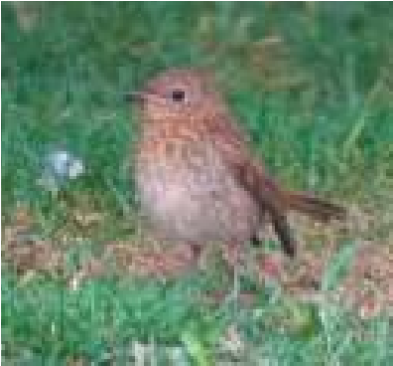
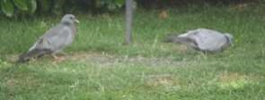
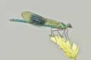
baby birds coming into the garden all day long. Even the great spotted woodpecker parents and babies are and the stock dove with it’s well grown youngster.
damsel fly
–

actually a
‘
banded demoiselle
’
(
I checked
coming in individually.
Here are some pictures
taken recently in the
garden
–

the baby robin
Then a special one: Barry managed to get some great pictures of a real rarity at Bempton Cliffs, a red tailed shrike. There have only been about 20 recorded sightings in the UK so this is a bit special!” (opposite page)

Middleton book group
August Books Two books with some similarities were this months collection.

Men Don’t Cry by Faisa Guene followed the life of Mourad and his family in Nice. His father spends days fixing up things in the backyard; his mother bemoaning the
loss of her natal village in North Africa. The eldest sister Donnie is a staunch feminist; Mina the youngest blushes when the shower ad comes on. Mourad is torn between a desire for freedom and his fear of becoming an overweight bachelor with salt and pepper hair. He does move away with his fathers words “men don’t cry” and “find your sister”, both of which haunt him through his life.

The second book, The Vanishing Act of Esmeralda Lennox by Maggie O,Farrell, is set between the 1930s and the present. It is the story of Esme a woman edited out of her family and the secrets that come to light when, sixty years later, she is released from care and her great niece Iris discovers the aunt she knew nothing about. Esme was a fiercely intelligent unconventional young woman raised with her jealous sister in India and Edinburgh and the rivalry and betrayal which led to a stunning imagining of a life stolen and reclaimed.
Kate
The next books for discussion: The Storyteller of Casablanca by Fiona Valpry
The Midnight Library by Matt Haigh

Meetings are on the second Tuesday in the month in member’s homes - Contact Lyn for further details: 219500 or lyndennis456@gmail.com
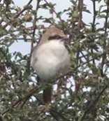
Nearer to home, Tophill Low nature reserve remains closed while extensive work is carried out. You can find out what is going on by visiting tophilllow.blogspot.com which has lots of info and interesting pictures. Let’s hope it re-opens in the autumn.
In the meantime, please let me know if you see anything interesting – or if you would like to join the Village Hall Committee (but that’s another story!) Barbara
lavenderbarbara97@gmail.com or 0777 192 7868

parish council news
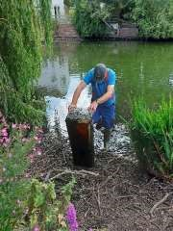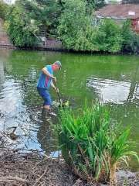

PARISH COUNCILLOR FISHING SURPRISE!

No, Nick Jones didn’t find anything in Middleton Pond for his supper, just a traffic bollard, an alarm clock and a bottle.
The low level of the pond revealed these treasures and he kindly donned his waders and removed them.

JUBILEE MUGS
Following the recent distribution of the Jubilee mugs to those residents of a pensionable age there are still some mugs available. These will be available for collection from the Village Hall on Thursdays throughout September from 2.003.30pm (only). If you haven't got one yet don’t be a mug, be a Jubilee mug!
Draft Climate Change Strategy Consultation

ERYC are developing a Climate Change Strategy for the East Riding. They are keen to hear the public's thoughts on the draft material, hence, a survey which is now in the final stages of development. It will run until the end of September. Follow the link to complete the survey

https://consultation.eastriding.gov.uk/s/
DraftClimateChangeStrategyConsultation/

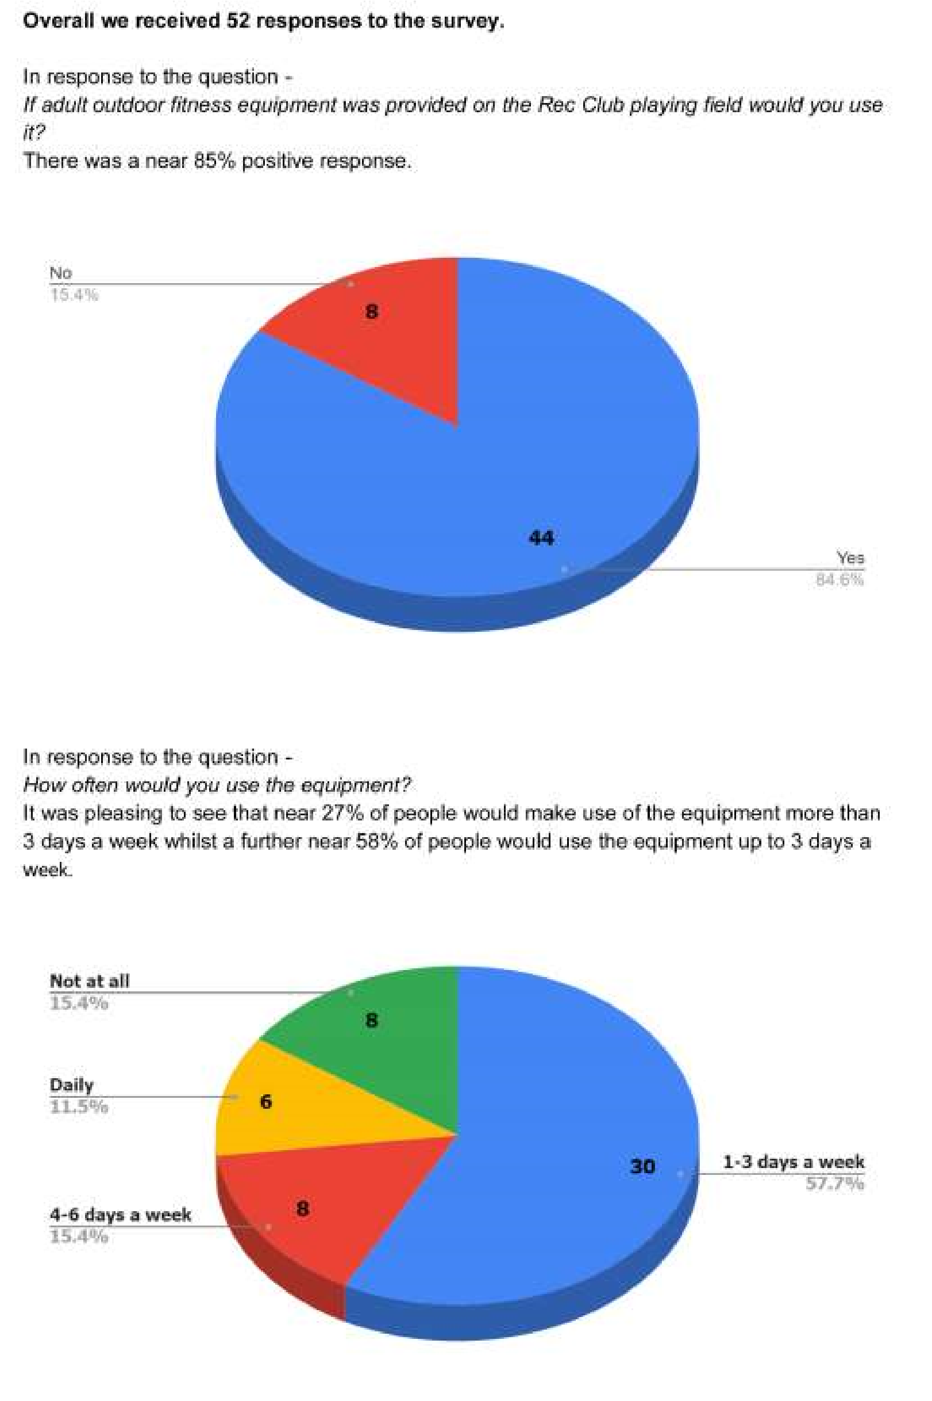

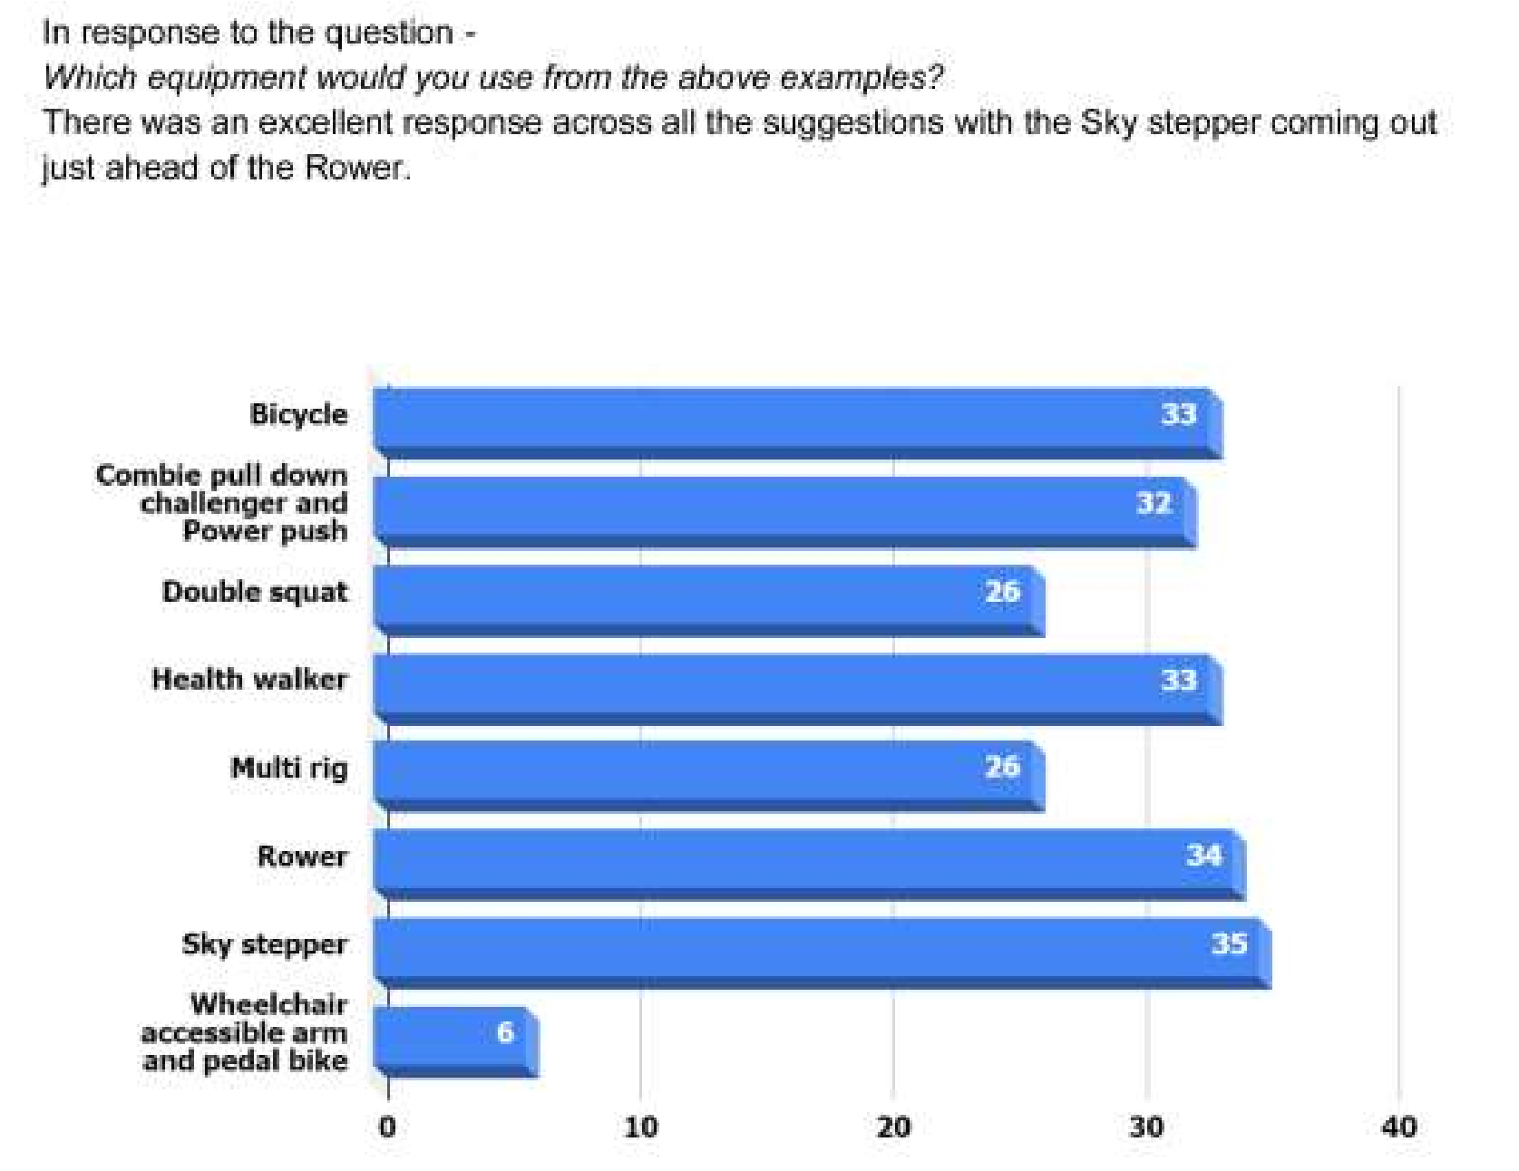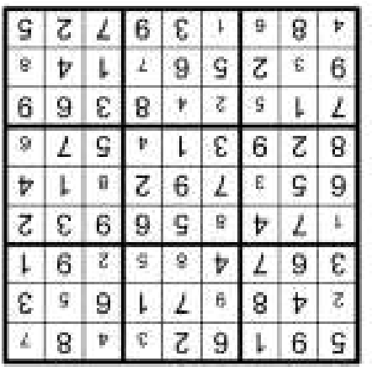
BACK AT SCHOOL

QUIZES
1

Cakes.

2

The Beatles.

3

Cleopatra.

4

Indian Ocean.

5

Alderney.

6

Little Women

7

Antarctica.

8

Coffee.

9

Bobby.

10

Horse racing.

LOCAL HISTORY
TUDOR TURMOIL

With the accession of Henry the seventh in 1485, the first of the Tudor monarchs, the new style of kingship of Edward the fourth was continued and the next century was to prove highly significant in the history of England both locally and nationally with questions concerning religion playing a big part.
Henry, an effective if less than popular monarch, ran a tight ship and without the need for a standing army to service foreign adventures maintained healthy finances. The same cannot be said for his son, the colourful and ultimately ruthless Henry the eighth whose marital and reproductive problems together with financial waywardness are among the most widely known and dramatized facts in that ripest period of English history. The refusal of Pope Clement the seventh to grant him a divorce from his wife Catherine of Aragon who had previously been married to his deceased brother Arthur and who had failed to produce a male heir would prove to be the starting gun for the transformation of religious practice in the country.
Henry, hitherto a staunch defender of catholicism was content to remain in the faith despite the growing pull of the Lutheran alternative of which he did not approve; but with the proviso that he himself was head of the Church in England instead of the Pope: this he achieved. The country’s established religious institutions with their considerable wealth also made a tempting target for the cash strapped monarch and in this he was aided by his chosen hitman: Thomas Cromwell, the low born, clever and efficient perpetrator of the process known as the Dissolution of the Monasteries, who was himself more in tune with new religious thought than his master. As was to be expected the cast of characters involved in these events varied from the profoundly religious, willing to die for their faith to those indifferent to doctrinal niceties but eager for material gain and its retention come what may. One of Henry’s last acts was the sanctioning of the bible in an English translation which eventually led to a growth of evangelical doctrines of which he would not have approved.
Henry was succeeded in 1547 by Edward, his only male heir, the product of his marriage to his third wife Jane Seymour who died soon after her son’s birth. He, with the aid of unscrupulous advisers, often with ulterior motives, adopted strong Protestant practices and under the pretext of suppressing idolatry carried out a massive plunder of church fabric, once again enriching the favoured few and robbing the country of priceless treasures.
The short lived Edward was succeeded in 1553 by Mary, Henry’s daughter with Catherine of Aragon. A sincere catholic but politically inept she tried to re-establish the faith: ultimately she failed. Married to Philip of Spain, the more politically savvy of the two, the union did not produce the much sort after heir. She is remembered today for the burning of three hundred Protestants, a war with France and the loss of Calais, England’s last French possession. Philip survived to instigate the 1588 Spanish Armada and the attempt to remove Queen Elizabeth, restore the catholic faith in England and maintain Spanish supremacy in the international power game. He had also offered to marry Elizabeth soon after the death of Mary.
So it was left to Mary’s successor Elizabeth the first, the daughter of Anne Boleyn and arguably one of England’s greatest monarchs, who by not publicly showing strong religious convictions was able, after much trial and error, to find a solution of sorts to the doctrinal question with a light touch approach. This involved creating a system of belief and religious worship, often by loose wording which was open to different interpretations and designed to encompass both the catholic and reform aspects of religious practice: in other words the beginnings of the Anglican Church with the monarch as the supreme governor. This settlement also allowed the clergy to marry thereby enabling son to succeed father and thus creating a clergy with more of the characteristics of family life. In addition the village parson often became a close ally of the Squire; but it did not of course settle the religious question so that the catholic and the more puritanical elements of the population had to bide their time and tread carefully.
Any easy acceptance by the catholics of the compromise settlement however was dealt a blow in 1570 by the papal bull issued by Pius the fifth which sought to destroy the allegance of Elizabeth’s subjects by excommunicating her and denying her legitimancy as the English queen with the implication that true catholics had a duty to rebel against her rule. To this end colleges were established abroad to create highly trained and motivated priests ready to serve in England and if necessary sacrifice their own lives for the cause.
Meanwhile the ambitions of the puritanical members of the protestant faith would have to wait until the next century for their wider intrusion into the religious practices of the population; and the catholic cause received a further setback in 1605 when the gun powder plot, the remembrance of which is etched in the collective memory of the English, was stopped at the last minute from toppling the new Stuart dynasty.
In the next article we can see how some of these events affected life in East Yorkshire.
Geoff Wisher

private sales
Laser print Baroque  Blue RUG. Size  120x70 cms. Retails at  £130 but will accept £50. Brand new and unused. We all make mistakes and this was my expensive one!  Ideal for lounge or  bedroom or Summerhouse.  Original Aluminium  Mermaid Steamer/  Fish Kettle  45x30x27cms.  Nothing fishy about this classic steamer,  ideal for cooking the Xmas Salmon, or for use as a smoker. Will accept £20 for this timeless classic!  Interested? Contact Nick on  07788494324 or email njones40@sky.com | FOR SALE  Isofix Mothercare Havana  Car Seat  Excellent condition. Only used in grandparent’s car. £30.00  Mothercare Fruit Salad  Highchair  Good condition. £15.00  Sue Howden 01377 217279
Advertising Feature

Advertisements
Advertisement

Advertising Feature

Regular group activities
Weekly Groups
Monday Pilates |  | 5.00-6.00pm Village Hall
Tuesday Tai Chi |  | 2.30-4.00pm Village Hall
Wednesday Line Dancing |  | 7.30-9.00pm Village Hall
Thursday Middleton Movers  September |  | 2.00-3.30pm Village Hall
5 Parish Council |  | 7.00pm Village Hall
6 Village Hall Committee |  | 7.30pm Village Hall
13 Book Group |  | 10.30am Station Road
25 Womblers Litter Picking |  | 10.00am Lime View
 | LOCAL CONTACTS Bell Ringing Chris Atkin |  |  | 217285
 | Book Group/Middleton Movers |  | Lyn Dennis | 219500
 | Bowls Club |  | Rob Bradley | 217435
 | Country Women’s Association |  | Christine Johnson | 217374
 | First Responders |  | Chris Brent | 219469
 | Line Dancing |  | Pat Pottage | 217516
 | Methodist Chapel |  | Jane Gray | 07870 562455
 | Middleton Messenger |  | Mike Kelly | 07713 620912
 |  |  | Lyn Dennis | 219500
 |  |  | Tina Walker | 217242
 | Middleton Green Group |  | Liz Naylor | 219072
 | Middleton Womblers |  | Andrew Naylor | 219072
 | Parish Clerk |  | Sandra Morrison | 01262 470496
 | Pilates |  | Ian Stephenson | 07973 755717
 | Reading Rooms |  | Kath Bentley | 217456
 | Recreation Club |  | Dave Newlove | 07901 833784
 | St Andrew’s Church |  | Rev Jane Anderson | 219471
 | St Andrew’s Church Wardens |  | Chris Brent | 07766 162743
 |  |  | Lesley Kelly | O7907 451046
 | Table Tennis |  | Louise Newlove | 217801
 | Village Hall |  | Lyn Dennis | 219500
 | Village History Geoff Wisher |  |  | 217517
email: middletonflyer@yahoo.com page 24

